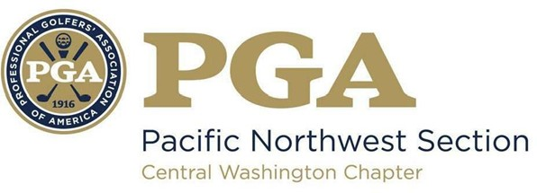
2023 CWC PGA
LES SCHWAB JUNIOR GOLF
GRANT PROGRAM

The Central Washington Chapter PGA is proud to introduce the second annual Les Schwab Junior Golf Grant Program! This initiative reflects the commitment from Les Schwab to support our Chapter and grow the game for junior golfers in the great Pacific Northwest! Our goal is to provide as many grants as possible, with a maximum of $1,000 per grant.
This opportunity is open to all Central Washington Chapter Members and Associates in good standing who seek funding to help support their own Junior Golf programs of any size. Funds can be put towards any of your program needs to help grown the game for local junior golfers! Examples include golf clubs, tee prizes, training aids, gear, prizes, ect. The Chapter Executive Director and Les Schwab leadership will consider all requests and your applications will help us expand our vision on what programs should be considered.

Complete the form below and email it to jeberle@pgahq.com
Deadline = May 1st, 2023

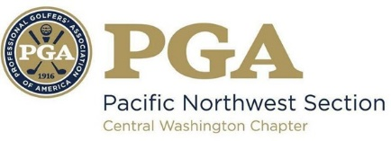
CWC PGA
LES SCHWAB JUNIOR GOLF
GRANT APPLICATION

PGA Professional: ____________________________________________________________ _________
Facility: _____________________________________________________________________________
Email: ____________________________________ Cell Phone: __________________________
Program/event date(s): _______________________________________________________________
How many juniors in the program/event(s)? _______________________________________________

- Provide a short summary of the junior program you are requesting funds to support

- Tell us specifically how funds will be utilized & support junior golfers

- How will you be able to incorporate the Les Schwab logo/name when advertising before or during your program/event(s)?

- Any additional comments or information, please list below
Complete form by May 1st & grant winners will be announced no later than June 1st

