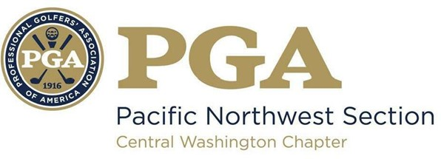
2024 CWC PGA
LES SCHWAB JUNIOR GOLF
GRANT PROGRAM

The Central Washington Chapter PGA is proud to introduce the 3rd annual Les Schwab Junior Golf Grant Program! This initiative reflects the commitment from Les Schwab to support our Chapter and grow the game for junior golfers in the great Pacific Northwest! Our goal is to provide as many grants as possible, with a maximum of $1,000 per grant.
This opportunity is open to all Central Washington Chapter Members and Associates in good standing who seek funding to help support their own Junior Golf programs of any size. Funds can be put towards any of your program needs to help grow the game for local junior golfers! The Chapter Executive Director, Player Development Chair, and Les Schwab leadership will consider all requests and your applications will help us expand our vision on what programs should be considered.

Complete the form below and email it to both jeberle@pgahq.com & dmarconi@pgahq.com
before May 1st
Grant winners will be announced no later than June 15th

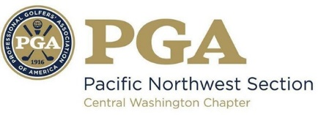
CWC PGA
LES SCHWAB JUNIOR GOLF
GRANT APPLICATION

PGA Professional: ____________________________________________________________ _________
Facility: _____________________________________________________________________________
Email: ____________________________________ Cell Phone: __________________________
Program/event date(s): _______________________________________________________________
How many juniors in the program/event(s)? _______________________________________________

- Provide a summary of the junior program(s) you are requesting funds to support

- Tell us specifically how funds will be utilized & support junior golfers

- How will you be able to incorporate the Les Schwab logo/name when advertising before or during your program/event(s)?

- Any additional comments or information, please list below

